YouTube Content Creating And Marketing

How to create content without showing your face

Copy different kind of videos from YouTube or different source and then combine it to make a single video.

Just like how edureka is doing, they combine different section of a single topic and make it a single full course video

How to go viral on YouTube:

Add meta-data to your video title, description and tags. meta-data represent keywords about the video.

And make sure you have some similar text around all your images, so that YouTube can recommend your videos to your

Viewers right after they are about to Finnish watching a single video

YouTube Earning Tips

1. On YouTube the number of views that your videos get each month is more important than the number of subscriber. Because that’s what bring in the money.
2. Focus your channel on a single niche. Because that is what will increase your “cpm” on advertisers biding on YouTube ads. This will increase your earning each on each view.

**YouTube SEO**

1. YouTube Search: works 20%

This is where users types some keywords in youtube search box.

The key is to type your topic in the YouTube search bar. As you type, YouTube will show dropdown with suggestions which are all phrases people are searching for.

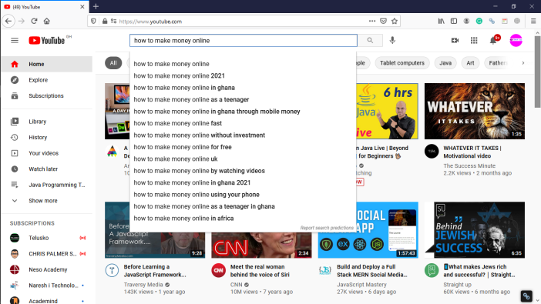

Create a video with one of these phrase in your title and two of it in your description. And you will get more luck of people searching for this topic.

1. Similar Video Recommendation: works 43%

This is where YouTube recommend your videos to others after watching similar one.

The key is that, you have to find the most viewed similar video of your target keyword. And try and get your video recommended after it.

You can do this by searching for some phrase in YouTube and sort ib by “view count” for find the most viewed video on that phrase. Then pay close attention to the keywords used in the title of that video. Then include it in your video title.

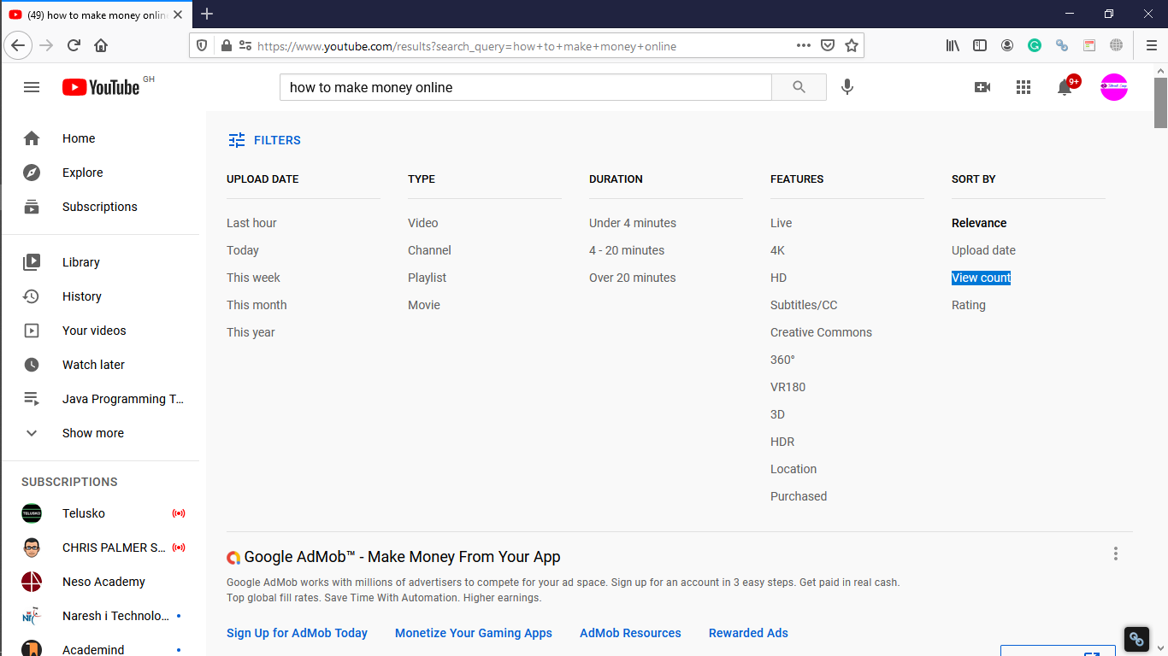

Focus on Quality over Quantity In Everything (Both YouTube And Blogging)

You need to put in much effort to create good quality video where people will watch and watch than uploading videos everyday where no one is interested in watching.